System Dynamics & Agent-Based approaches to face HR constrains

Guttenberg Ferreira Passos  Programa de Pós-graduação  Universidade de Brasilia  Brasilia, DF, Brasil  gut.passos@gmail.com | Ilan Chamovitz  Manchester Business School  The Manchester University  Manchester, United Kingdom  ilan@api.adm.br | Babis Theodoulidis  Manchester Business School  The Manchester University  Manchester, United Kingdom  b.theodoulidis@manchester.ac.uk
Key-words: System, Dynamics, agent, simulation, constrains

Introduction

Human Resource Management (HRM) has emerged as a fundamental and critical capital in organizations. After all, human resources plan, design policies, handles machinery and innovates. Human Resources hire human resources. In this context, information systems can facilitate the understanding of problems, especially when there is a complex scenario involving decision making. Thus, investment in HR Information Systems becomes increasingly valued by managers.

Dutra (2002, p.17) characterizes the People Management as "a set of policies and practices that enable the reconciliation of expectations between the organization and the individual so that both can carry them over time." Thus, Human Resource department target comprises managing organization relationships with individuals who compose it, taken today as “business partners and not mere corporate resources."

Research and Innovation teams compose an interesting scenario where workers should be allocated for performing tasks related to their skills. According to Chiavenato (2009), the organisational structure, when oriented-to-competency management, should be totally different from conventional and traditional organisational structure. For this reason it also requires a different organizational and cultural context. That is, rather than isolated positions and stable and permanent departments, innovation and technology-driven management must be focused on professionals and should offer integrated, compliant and flexible multifunctional teams equipped with complementary skills and abilities. Thus, one of the main elements of competency management in this scenario is the dynamic aspect.

To better understand and manage the production’s capacity in research, technology and innovation teams, aligned with skills management in a dynamic and complex environment, this paper suggests the adoption of System Dynamics and Agent-based modelling.

System Dynamics is a method to enhance learning in complex systems. It is fundamentally interdisciplinary, grounded in the theory of nonlinear dynamics and feedback control developed in mathematics, physics, and engineering (Sterman, 2001). Aging chains is a well-known and quantitative method from supply chain management, that consider changes in a group along some period, during a simulation. The idea to apply it to a human resource management problem is not new. Größler & Zock,(2010) used a system dynamics model to improve the recruiting and training process in a large German service provider, in the wider field of Logistics. However, the idea of suggesting Modelling Based Agents (ABM) to follow the aging chain study could provide supplemental information for managers.

The human resource allocation model is part of Tower 5, presented by Organizational Responsibility Model (Guttenberg, Chamovitz & Theodoulidis, 2013). This model suggests that after completion of the survey of people need through the Capacity Plan, begins the process of hiring employees in accordance with the suggested number. The life cycle of the employee in the company is represented with Aging Chains proposed by John Sterman model (2001). It was adapted and build using two approaches: System Dynamics and Agent-Based modelling.

System Dynamics approach (figure 1) considers three states for the worker: the new employee means a trainee, and for the context of the article it can be understood as postgrad student, a master or doctorate candidate entering a research team, for example. By gaining more experience, and an academic title, the student status turns to a “prepared worker”, and could be named as "Employee", representing as a recent researcher. As time goes by and with the gain of experience, this researcher becomes a "Master" or is considered a “Senior”. Then he stays at this level until his retirement.

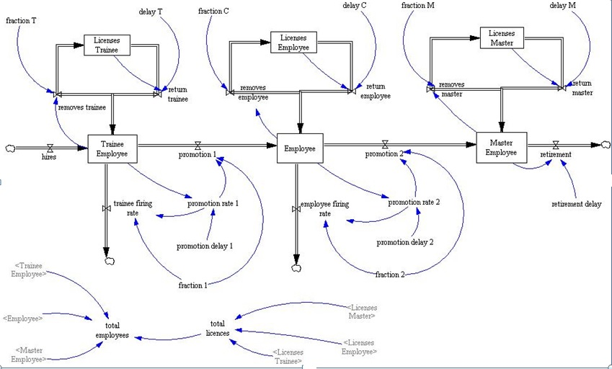
Figure 1. Dynamic model based on aging chains

In summary, in this model career’s researcher evolution is mapped taking into account these 3 steps, including promotions and absences from work, considering time, from hiring to retirement. The period between hiring and retirement is not the same for each researcher and the evolution of each one depends on a number of factors which are represented in the model as “training”.
During this cycle there is a possibility of one or more delays, that lead the employee on taking a certain time to pass from a beginner researcher to more experienced one. There may be a delay too to get over the stage of “Master” to finish his career at the organization, as a “Retired”. Furthermore, retirement not always occurs at the end of the process, because the cycle can end prematurely during intermediate stages, due to emergencies. System Dynamics approach provides an overview of flow that facilitates the perception of all stages with changing conditions and scenarios that arise in a given situation.

The second approach comes from Agent Based modelling within simulation. Franklin and Graesser (1997) define an autonomous agent as "a system situated within and a part of an environment that senses that environment and acts on it, over time, in pursuit of its own agenda and so as to effect what it senses in the future".
Bandini, Manzoni Vizzari (2009) first present computer simulation as the usage of a computational model to gain additional insight into a complex system's behaviour, than give some examples of areas where simulation can be applied for better understanding a situation, such as biological or social systems, or for further real implementations, such as architectural designs, road networks and traffic lights. Several platforms are available for the use of ABM. Railsback, Lytinen and Grimm (2006) present a review and compare platforms MASON, NetLogo, Repast. Java and Objective- C versions of Swarm.
The agent-based model (figure 2) was build using Netlogo, a programming environment that allows the simulation of natural and social phenomena. Netlogo was created by Uri Wilensky in 1999 and is continuously developed at the Center for Connected Learning and Computer-Based Modelling. The website for access is in http://ccl.northwestern.edu. In Netlogo there are 4 types of agents: turtles (elements that circulate in the environment, on the patches), patches (cells, static, that take one or more states), links (relations between turtles) and, finally, the observer.

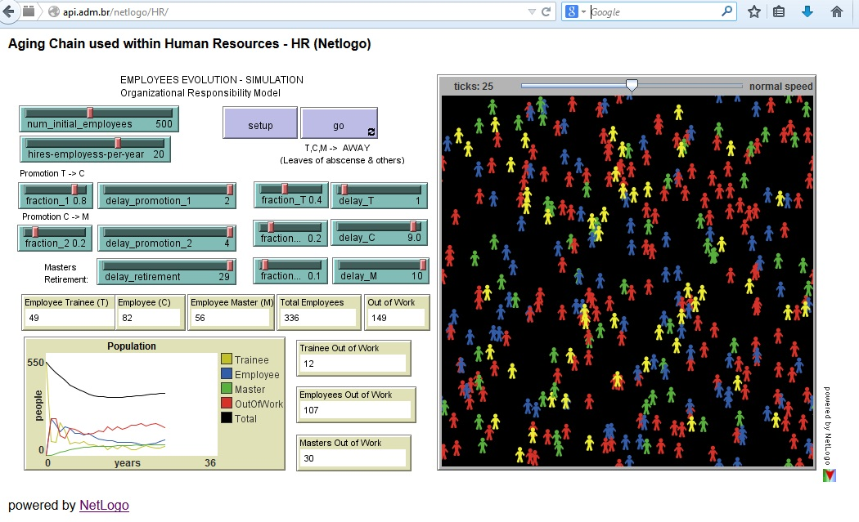
Figure 2. HR model based on aging chains
As one can see in business environment, also in research projects a good plan usually involves calculated risks. After all, if on one hand it is possible to preview a retirement of a senior researcher with advanced working age, on the other hand it is impossible to predict that a recent hired employee will become ill. For managers, an information system in human resources could simulate different scenarios and consider the possibility of relocation researchers in projects, covering the possibility of having a higher level of absence.

HR model proposal
Agent Based Modelling flows from micro to macro, studying the emergence in the system caused by the interaction of an agent with the others and with the environment.
In research development, some political or strategic interventions can suppress hiring for a while. In these cases, human resources must be relocated in the institution. Managers need to decide if and when people will be displaced to fit all needed demand. Furthermore, this decision should consider possibilities of absences and retirement, beyond the level of researcher’s expertise.
The life cycle of the employee in the company is based on the chain of Aging (Aging Chains) model proposed by John Sterman in the book Business Dynamics: Systems Thinking and Modeling for a Complex World. Staff evolution model can map the evolution of professionals’ careers, taking into account PROMOTION and OUTFLOW along employee life cycle, from hiring up to retirement.
During this cycle there is a DELAY that makes the employee takes certain time to pass from beginner to more experienced positions. There is also ANOTHER DELAY for the employee to pass from the last employee stage, master, to finish his career at that company. The closure can be prematurely finished, along the intermediate stages.
The model was adapted from the original to allow SHORT-TERM OR LONG-TERM LEAVES, and the main consequence is the consequent delay for their evolution/promotions, causing the employee to remain longer at each stage.
Agent Based Modelling allows modelling each agent individually. For this model there is a PROBABILITY for each different agent leaving the company, as well as a different TIME for the agent to STAY TEMPORARY OUT of the company.
The model then allows the manager to perform simulations changing parameters until he gets to a number of hires that allows, through the replacement of staff, to keep company with a suitable crew to keeping running it’s services.
Main elements of HR model
The main elements of the model presented on figure 3 are described as follows:
AGENTS (employees) can assume 3 different STATUS:
- Employee-Trainee (T) is true when the agent is a beginner
- A common Employee (C) is true after beginners promotion
- Employee-Master (M) is true after Employee promotion
When an AGENT is OUT OF THE COMPANY, his status assume values as follows:
- Trainee_OutOfWork (T) is true if a beginner is out
- Employees_OutOfWork (C) if true if common employee is out
- Masters-OutOfWork (M) is true if master is out
The system starts with all employees being trainees and no one out of company. The number of employees hired along the year represents the quantity of new employees that are inserted in the system, in the beginning of each New Year.
Along the time, the 3 groups of agents (T, M, C) age. Fraction-1 determines a fraction from the quantity of trainees that will be promoted. The others will be out from the company, fired, or by choice. For example, if fraction-1 is set to 0,8 means that 20% will be fired (or will leave definitely the company) and 80% remains and can be promoted. This is common in a public company, in Brazil.
The field delay-promotion-1 defines how long (years) does it takes to be promoted from trainee (T) to common employee (C). The field Fraction-2 determines a fraction from the quantity of common employees that will be promoted. The others will be out from the company, fired, or will leave by choice. For example, if fraction-2 is set to 0,9 means that 10% will be fired (or leave definitely) and 90% remains and can be promoted . This or other value could be applied to a private company.
The field delay-promotion-2 defines how long (in years) does it takes to employees to be promoted from C to M.
- Fraction-T randomly gives the number of trainees that were away that year. Delay-T randomly gives the number of trainees that came back to the company after being away.
- Fraction-C randomly gives the number of common employees that were away that year. Delay-C randomly gives the number of common employees that came back to the company after being away.
- Fraction-M - randomly gives the number of masters that were away that year. Delay-M randomly gives the number of masters that came back to the company after being away.
Delay-retirement - defines the number of masters that left for retirement that year.
Whilst AGING, part of each group will be PROMOTED, as follows:
- Employees-to-be-promoted = (Employee / delay-promotion ) * fraction. (fraction-1 controls promotion and delay from T to C and fraction-2 controls promotion from C to M )
The other part of each group that is not away REMANIN WORKING AT THE COMPANY – This is calculated as follows:
- Employees to stay at incompany = ( Employee / delay-promotio ) * ( 1 - fraction )
Part of each group will LEAVE TEMPORARY the company (i.e. on license, illness) -
This is calculated as follows:
- Employees to leave temporary = ( Employee * fraction )
Part of each group will RETURN TO THE COMPANY and this is calculated as follows:
- Employees returning to the company = OutOfWork / delay )
The model also identifies the number of people needed to keep the amount of stable staff. Thus, it is possible to adopt a permanent policy of replacement workers as shown in figure 3.

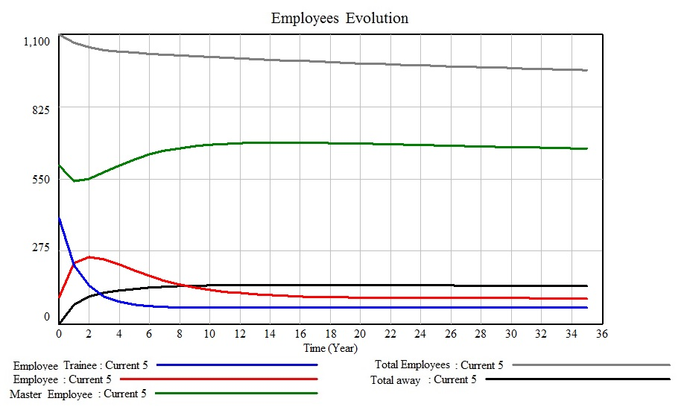
Figure 3. Permanent policy of replacement workers

Conclusion

There are some situations where the adoption of such type of policies results in constrains, such as impossibility of hiring of people. The proposed model has been applied for a public service ICT software development company, in Brazil. At that time, hiring staff or services met strict criteria established by law and policies. Based on outputs from system dynamics (SD) followed by Agent Based Modelling (ABM), managers could decide about relocation of people, following defined policies, without hiring staff.

REFERENCES

ANDRADE LD, LYNCH C, CARVALHO E, RODRIGUES CG, VISSOCI JRN, et al. (2014). System Dynamics Modeling in the Evaluation of Delays of Care in ST-Segment Elevation Myocardial Infarction Patients within a Tiered Health System. PLoS ONE 9(7): e103577. doi:10.1371/journal.pone.0103577. < http://www.plosone.org/article/info%3Adoi%2F10.1371%2Fjournal.pone.0103577 >

BANDINI, Stefania, MANZONI, Sara and VIZZARI, Giuseppe (2009). 'Agent Based Modeling and Simulation: An Informatics Perspective'. Journal of Artificial Societies and Social Simulation 12(4)4 <http://jasss.soc.surrey.ac.uk/12/4/4.html>

CHIAVENATTO, Idalberto.(2009) Treinamento e desenvolvimen
to de recursos humanos. 7. Ed. Barueri, SP: Manole, 2009.

DUTRA, J.S.(2002). Gestão de pessoas: modelo, processos, tendências e perspectivas. São Paulo: Atlas, 2002

E SILVA, L. C., & COSTA, A. P. C. S. (2013). Decision model for allocating human resources in information system projects. International Journal of Project Management, 31(1), 100-108.

GRÖßLER, A., & ZOCK, A. (2010). Supporting long‐term workforce planning with a dynamic aging chain model: A case study from the service industry. Human Resource Management, 49(5), 829-848.

FRANKLIN, S., & GRAESSER, A. (1997). Is it an Agent, or just a Program?: A Taxonomy for Autonomous Agents. In Intelligent agents III agent theories, architectures, and languages (pp. 21-35). Springer Berlin Heidelberg.

PASSOS, Guttenberg Ferreira; CHAMOVITZ, Ilan; THEODOULIDIS, Babis. (2013). Organizational Responsibility Model: Dealing with Demand for Services Higher Than Installed Capacity. In: Systems, Man, and Cybernetics (SMC), 2013 IEEE International Conference on. IEEE, 2013. p. 4415-4420.

RAILSBACK Steve , LYTINEN Steve , GRIMM Volker.(2006). Agent-based simulation platforms: Review and development recommendations. Simulation, 82:609{ 623, 2006. Disponível em http://www.humboldt.edu/ecomodel/documents/ABMPlatformReview.pdf . Acesso em janeiro de 2012.

STERMAN JD.(2000) Business Dynamics: Systems Thinking and Modelling for a Complex World. Boston, MA: Irwin/ McGraw-Hill; 2000.

STERMAN, JD (2001) System dynamics modelling: Tools for learning in a complex world, California Management Review , Vol. 43, No. 4, Summer, pp. 8-25

